Initial Project Proposal

Year: 2023 Semester: Fall Project Name: Air-Hockey Playing Robot

Creation Date: June 27, 2023 Last Modified: July 9, 2023

Team Members (#1 is Team Leader):

Member 1: Abigale Haluska Email: ahaluska@purdue.edu

Member 2: John Morton Email: morton67@purdue.edu

Member 3: Joey Collins Email: colli384@purdue.edu

Member 4: Cameron McCutcheon Email: mccutchc@purdue.edu

1.0 Description of Problem:

The problem we are trying to solve is providing a consistent and accessible way for air hockey players to practice and train. Air hockey players need a partner to practice against that can match skill levels, perform certain plays, and provide a challenge. Other people may not be available or have the right skill level. This affects anyone who has an interest in playing air hockey  
  
Air hockey is one of the most popular arcade games out there and has a lot of potential for enhanced experience with robotics. Games like chess, golf, and table tennis have had a lot of advancements in the robotics field. These games have greatly benefited from the addition of robots to practice against and have grown a larger and more active player base as a result. Air hockey would experience a similar boost in popularity and growth if development in robotics for the game got on the same level.

2.0 Proposed Solution:

Our proposed solution is to create a robot that can play air hockey. An air hockey robot can play at any skill level, provide training, and act as a partner practice. The robot is always available and can provide a good challenge.

Our robot would serve as an attachment to any functioning hockey table. Simply attach the robotic apparatus to an air hockey table, and turn on the device to begin playing. The modularity of our solution distinguishes our design as it enables users to easily transition between playing with a human player versus playing against a robot.   
  
The robot we build is going to use a combination of computer vision, cables, and motors to detect where the puck is and move the mallet. Once the puck is detected, its current trajectory is used to model where it is most likely to go and the robot can move the mallet accordingly depending on what play is to be performed. Ideally, it could perform a wide array of maneuvers and actions, but blocking would be a good place to start with.

3.0 ECE 47700 Course Requirements Satisfaction

3.1 Expected Microcontroller Responsibilities:

ECE 477 requires the use of a microcontroller that runs software developed and integrated by students. This project will employ a microcontroller to interface with the camera used to track motion on the table. The plan is to have a Raspberry Pi running a server that the microcontroller will upload the video stream to. The microcontroller will then use the information received from the Raspberry Pi to calculate puck characteristics like current position and velocity. It will also be used to control the motors that determine the position of the paddle. The prospect of additional functionality is viable and likely.

3.2 Expected Printed Circuit Responsibilities:

**Computer vision section:**

In all likelihood, computer vision will need to run at a rate too fast for any microcontroller system. On average, air hockey pucks travel at or above 30MPH depending on level of play, meaning for a standard length air hockey table, that leaves at most 160 milliseconds to image process (at least twice to establish velocity vector), calculate trajectories, and move the robot gantry to the required location. Assuming a generously short window of 60 milliseconds to move the gantry, we are left with 100 milliseconds to process at least two images.

This *may* be possible to accomplish with a micro-controller depending on its clock speed and its optimizability. In which case, a dedicated machine-vision microcontroller will be used which will communicate with the motor-controlling microcontroller.

If a microcontroller cannot be clocked at a high enough speed to image process, a faster system will be required to accomplish the goals of the project (potentially a PI or a full PC). In which case, a PCB would not be required.

**Stepper Motor Control Section:**

Motor control will be accomplished via a PCB and microcontroller connected to either an off-the-shelf stepper motor driver (off PCB) or ‘directly’ connected to the phase windings. In either case from above, this section will sit on a dedicated PCB. With the microcontroller accepting coordinate values to move the gantry to, and converting it into steps for the motor to take.

Notably, the stepper motor will require higher voltage and amperes than the micro can provide. AC-DC conversion for the motor and micro(s) will be handled off PCB.

4.0 Market Analysis:

The lack of air-hockey playing robots in today’s market raises an interesting question: Is this a viable product that could attract buyers? The fusion of robotics and gaming technology is a steadily growing interest of consumers, who are actively seeking innovative and interactive experiences. Although there is not a large market for this type of product now, the team believes that an air hockey robot could appeal to enthusiasts and casual players alike. The most attractive selling point is the fact that it can serve as a practice companion for those who do not have access to playing partners. The robot’s ability to adapt to different skill levels makes it a unique experience for all types of players. As mentioned previously, this product appeals to a diverse range of potential buyers including enthusiasts and hobbyists. However, it could also attract the attention of commercial domains such as arcades and entertainment oriented businesses. The versatility of the product leads the team to believe that this is a viable idea to pursue.

When looking at the markets that our design might best fit into, we identified the Sports Training Industry and the Air Hockey Table Industry to be of relevance. After doing some initial research on the sizes of these markets, we identified the Sports Training Industry to be a starting total addressable market for us to benchmark more research off of. We then identified the Air Hockey Table Industry to be our serviceable addressable market. Through further research, we aim to identify a serviceable obtainable market related to the amount of air hockey players who train regularly.

The figure below contains data related to the size of the sports training industry and the air hockey table industry [1][2].

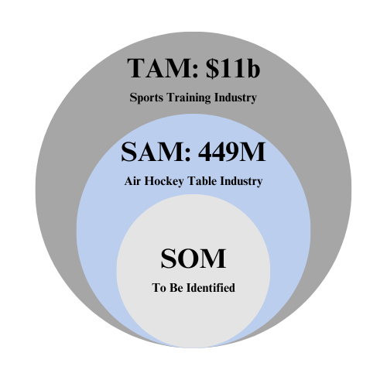

5.0 Competitive Analysis:

While there do exist current projects that share similarities with our prospective project, our team’s design was created to be easily accessible in regards to affordability, portability, and modularity. Throughout competitive analysis, our team found that there is a presence of air-hockey playing robots that are primarily designed to (1) be used by hobbyists and individuals in the DIY community or (2) be used in professional circumstances in which the robot was built to never lose. With that said, there remains opportunity for a design like ours to offer people an at-home form of entertainment that plays to the user’s skill level.

One example of a competitor whose design focuses on being replicable by hobbyists and the DIY community is the Air Hockey Robot EVO [3]. This competitor created a robot that was designed to be an open-source opportunity for others to construct air-hockey playing robots. While this design is strong in that it encourages the expansion of the air-hockey robot industry, it is affordable, and it is compact, the designs’ weaknesses involve its dependence on an end user with the materials and time to construct the robot as well as its dependence on a smartphone. Additionally, this robot does not possess any ability to match the end user’s skill level. In a game like air-hockey, where skill can range from novice to expert, having a robot that can only perform at one skill level reduces that robot’s target market. Finally, this robot is not easy to attach and detach, making it applicable to a smaller market. See the *Air Hockey Robot EVO* below.

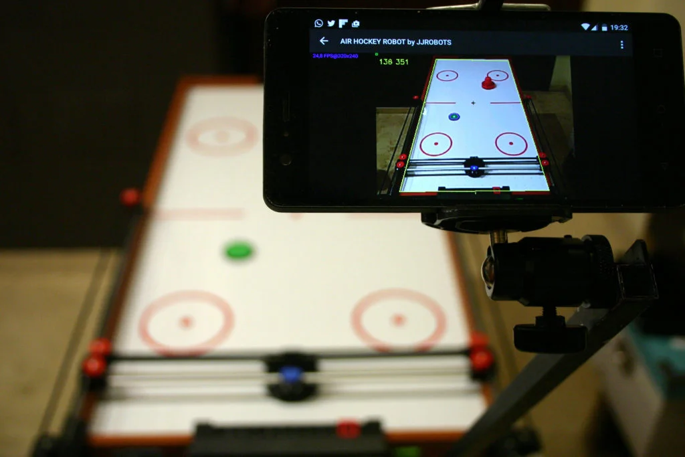

Another competitor that exemplifies a design focused on professional use and unbeatable accuracy is the Air Hockey Robot by Nuvation Engineering [4]. This product is a one-of-a-kind robot that consists of an advanced motor algorithm that blocks over 98% of the end user’s shots. While being marketed as virtually unbeatable is a strength in that it distinguishes this competitor from other competition, this robot is not designed to be used on a commercial scale. With that said, this robot's weaknesses include its high expense, its large physical build, and its lack of versatility. See the *Freescale Air Hockey Robot* below.

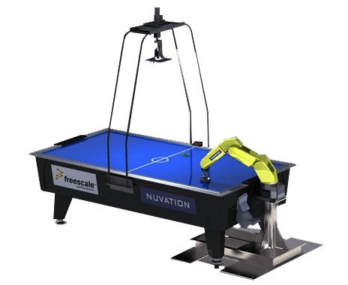

Competitive analysis enabled us to recognize strengths and weaknesses within competing products’ designs. While these competitors are similar to our product in that they both involve using computer vision to influence the robot’s movements, our robot remains unique in that it is user-friendly, versatile, and designed to be played at home.

5.1 Preliminary Patent Analysis:

5.1.1 KR20220105068A

Patent Title: Dynamic air-hockey using a interactive mapping technology

Patent Holder: [정웅희](https://patents.google.com/?inventor=%EC%A0%95%EC%9B%85%ED%9D%AC)[공형구](https://patents.google.com/?inventor=%EA%B3%B5%ED%98%95%EA%B5%AC)[이승한](https://patents.google.com/?inventor=%EC%9D%B4%EC%8A%B9%ED%95%9C)[장영하](https://patents.google.com/?inventor=%EC%9E%A5%EC%98%81%ED%95%98)

Patent Filing Date: 01/28/2020

The provided patent protects the design of a single-person air hockey robot. In contrast to the competitor products described in 5.0, the device protected by this patent was meant to provide an accessible form of leisure by eliminating the need for an opponent when casually playing air hockey [5].

The technology discussed in this patent involves a camera module being used to photograph a hockey puck on a table as well as a processing module to perceive displacement of the hockey puck. Additionally, the patent discusses the apparatus used to move the puck based on the processing module. The movements of the apparatus allow the puck to move forward, backward, left, and right. There exists a power unit at the front of the table to enable the movements of the puck.

The processing module discussed in this patent includes a Raspberry Pi module and an arduino board. To process the images taken from the camera, the images are first transmitted to the Raspberry Pi and are then converted to inputs for use in an OpenCV-based code. The image data is processed and transmitted to the Arduino board, in which the Arduino then controls the power unit and the guide units used in displacing the hockey puck.

This patent will be heavily considered throughout the design and creation of our air hockey robot.

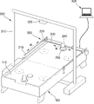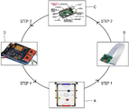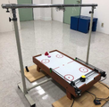

5.1.2 CN105922275A

Patent Title: Air Hockey robot based on movement sensor

Patent Holder: [彭良秀](https://patents.google.com/?inventor=%E5%BD%AD%E8%89%AF%E7%A7%80)[葛华](https://patents.google.com/?inventor=%E8%91%9B%E5%8D%8E)[孔子祥](https://patents.google.com/?inventor=%E5%AD%94%E5%AD%90%E7%A5%A5)[田应仲](https://patents.google.com/?inventor=%E7%94%B0%E5%BA%94%E4%BB%B2)

Patent Filing Date: 06/04/2016

The provided patent protects the technology and design of an air hockey robot that uses a movement sensor. In total, this design is a system of an air hockey table, ball, and striker system that allows left, right, front, and back movements of the puck [6]. With the movement sensor, this robot is able to locate the puck quickly and then adjust its location accordingly to counterattack the other user. This patent goes into depth on the types of sensors that might be used in counter reacting to the other play’s movements. It discusses the use of an integrated sensor using MEMS technology as well as a gyro sensor, geomagnetic sensor, and a micro-acceleration sensor.

This patent will be considered throughout the design of our project, particularly the design of the striker system.

5.1.3 US7854669B2

Patent Title: Trajectory detection and feedback system

Patent Holder: Alan W. Marty, Ridge McGhee, Thomas A. Edwards

Patent Filing Date: 04/02/2022

The patent protects the technology of a device used to provide trajectory detection and feedback to an object or objects moving in free flight. Using a machine vision system, the protected device can be used in tracking the movements of a basketball, hockey puck, or related moving objects. Based on the input to the machine vision system, the device will then output a diagnosis of the object’s movements as well as a prediction for the object’s future location [7]. The patent also discusses the intended use of the protected object, stating that the device protected might be used in professional or recreational sports and activities. This device may also be used in athletic training.

The device listed in this patent might include a power supply, a video capture card, a processor, a data storage device, RAM, and a trajectory analysis software. The device might also use WIFI to communicate with the imaging machine. Of the other patents analyzed, this patent is by far the most broad and protects a variety of applications.

When working on our project, this patent will heavily be considered as we write an algorithm that can track and predict the trajectory of a free-flight hockey puck.

5.2 Commercial Product Analysis:

Many of the air hockey table robots that exist are projects by hobbyists or large companies. These projects are often put on display, but rarely sold commercially. Because of this, our commercial product analysis focused on products related to air hockey and table tennis, as there are more table tennis robots sold commercially. Throughout commercial product analysis, we discovered that the only product similar to an air hockey robot that is being sold commercially is the Air Hockey Robot Evo kit, which is a kit of components that can be used to assemble an air hockey robot. This product is analyzed below.

5.2.1 Air Hockey Robot Evo Kit

Price: $130.00 [excluding shipping, filament, and assembly]

As mentioned in section 5.0, there exists an open-source air hockey robot kit that is marketed towards hobbyists and the DIY community. In addition to being an open-source project, this air hockey robot is also sold as a kit. This product sells for about $130 and it includes all physical materials needed to construct the robot apparatus [8]. The kit also includes the .STL files used to 3D print many parts for the robot, as well as the Github repository used to program the robot’s movements. While reading the reviews of purchasers of the Evo kit, it was determined that this product is marketed as an educational opportunity towards teachers in engineering and design.

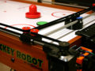

5.2.3 ZXMOTO Table Tennis Robot

Price: $417.00

This product is an automatic ping pong robot machine that is commercially sold for training table tennis. Given the product’s rotating head, adjustable jump ball, and adjustable oscillation frequency, the Table Tennis robot is versatile and applies to users of varying skill levels. Additionally, this product was designed for at-home use.

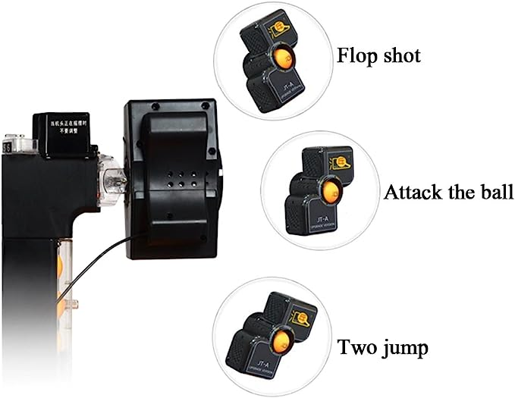

5.2.3 Custom Electronic Score Counter Air Hockey

Price: $165.00 [discluding shipping] [purchased in bulk]

This product is an electronic score keep that attaches to the base of an air hockey table. These products are sold to customers including Walmart, Joola, and Decathlon. Given that our product was designed to be an attachment to already existing air hockey tables, the Indoor Custom Electronic Score Counter is a commercial product that lightly resembles our team’s design. With that said, this product is only a means of tracking the score of an air hockey game, leaving a lot of contrast between this and other commercial products [9].

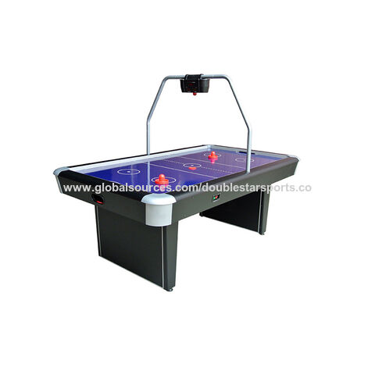

5.3 Open Source Project Analysis:

While there doesn’t exist abundant commercial competitors, the hobbyist and DIY community has made room for a significant amount of open-source projects related to air-hockey playing robots. The three projects described below are amongst the most popular and most referenced projects that we came across throughout open source project analysis.

5.3.1 Air Hockey Robot EVO

In addition to being mentioned in section 5.0 and 5.2, the Air Hockey Robot EVO was analyzed once more throughout researching open source projects. This project has been posted on various sites, most notably on instructables.com [2]. Created by user jjRobots, this project outlines all parts of the design process used to produce the Air Hockey Robot EVO. This project begins with a visual representation of how the air hockey robot communicates with a cell-phone to analyze imagery of the air hockey table. Following this step, the project then discusses how the robot is controlled by an app that is available on Google Play. While this step is interesting and differentiates this project from others, our team does not envision implementation of an app at the moment. A full bill of materials as well as links to the Github repository and the STL files used to assemble the robot are included on the project’s webpage. The project also includes detailed images of the mechanical assembly process and the programming process.

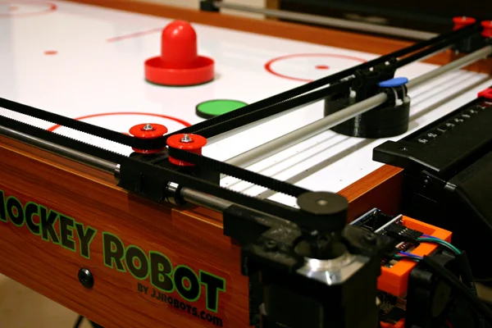

The Air Hockey Robot EVO is considered the most competitive product that our team has identified throughout the research process; however, our project remains distinguished by its dedication to the end user. Unlike the robot EVO, which is sold as an assembly kit for hobbyists and enthusiasts, our air hockey robot will be marketed as an attachment to any air hockey table, making it easy for non-hobbyists to play their own game of air hockey. Furthermore, our design will use feedback to enhance the game experience for the end user.

5.3.2 DIY Low Cost Air Hockey Table

This article outlines the steps necessary to construct a DIY, low-cost air hockey table in the comfort of one’s own home [10]. With over 25 steps in total, this project outlines the entire design process. Similar to the project outlined in 5.3.1, this project provides a list of all hardware components needed to construct the robot. Additionally, .rar files are provided to replicate the 3D printed components used in assembly. While this project shares similarities with the EVO robot, this project is unique in that it is focused more on the design process and less on the functionality of the robot. For example, the project’s web page discusses the use of a laser cutter and several other pieces of workshop equipment. Overall, this project is more involved than the project discussed in 5.3.1, but visuals make the project easy to follow.

Another distinguishing characteristic of this project is the 3D printed strikers and pucks. Unlike our project, the project described here puts an emphasis on “DIY” by making nearly every component from scratch. While some elements of this project might resemble design criteria related to our project, like the electronic scoring system, this project is quite different from our design in that it does not use computer vision and does not involve a robot that can play air hockey. With that said, this project will remain considered throughout our design process as it is an interesting example of how one can construct their own air hockey table with materials that can be found in a lab.

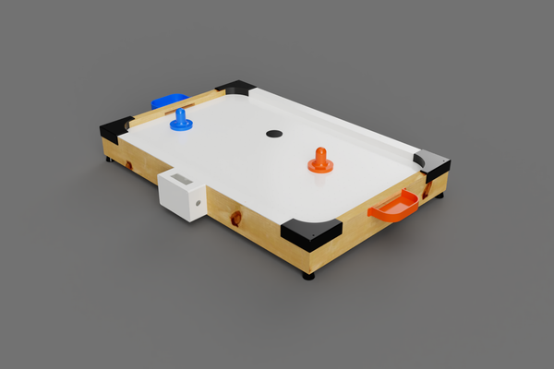

5.3.3 Open Source Project #3: AI Playing AirHockey

Unlike the projects discussed in sections 5.3.1 and 5.3.2, this project’s webpage outlines the implementation of a Python-based script that uses data from air-hockey games to train a model that can predict the trajectory of a hockey puck. While this project is not fully open-source in the way that the previous open-source projects are, the project’s web page provides great detail on the algorithms and methods used in producing the AI [11]. In addition, a visualization is provided to emphasize the computer model’s interaction with the physical hockey paddle. This project was published by the Barkhausen Institute of Germany.

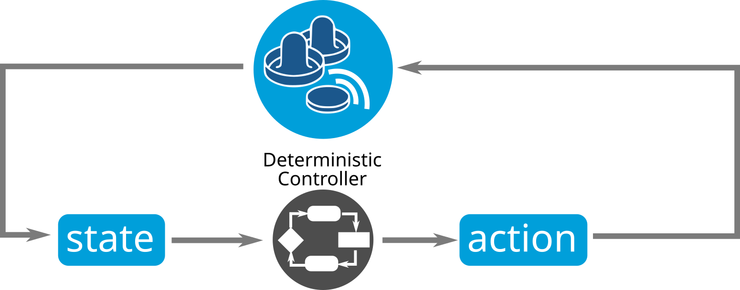

6.0 Sources Cited:*.*

[1] Allied Market Research, “Global sports training market is expected to generate $18.8 billion by 2031: Allied Market Research,” GlobeNewswire News Room, https://www.globenewswire.com/en/news-release/2023/06/23/2693614/0/en/Global-Sports-Training-Market-Is-Expected-to-Generate-18-8-Billion-by-2031-Allied-Market-Research.html#:~:text=Portland%2COR%2C%20June%2023%2C,5.7%25%20from%202022%20to%202031. (accessed Jul. 3, 2023).

[2] “Global Air Hockey Table Market - size, projections, drivers, trends, vendors, and analysis through 2021 by Technavio,” Global Air Hockey Table Market - Size, Projections, Drivers, Trends, Vendors, and Analysis Through 2021 by Technavio | Business Wire, https://www.businesswire.com/news/home/20170628005973/en/Global-Air-Hockey-Table-Market---Size-Projections-Drivers-Trends-Vendors-and-Analysis-Through-2021-by-Technavio (accessed Jul. 3, 2023).

[3] Jjrobots and Instructables, “Air Hockey Robot evo,” Instructables, https://www.instructables.com/Air-Hockey-Robot-EVO/ (accessed Jul. 3, 2023).

[4] “Air Hockey Robot,” Nuvation Engineering, https://www.nuvation.com/air-hockey-robot (accessed Jul. 3, 2023).

[5] “KR20220105068A - air hockey robot for single,” Google Patents, https://patents.google.com/patent/KR20220105068A/en?q=%28air%2Bhockey%2Brobot%29&oq=air%2Bhockey%2Brobot (accessed Jul. 3, 2023).

[6] “CN105922275A - air hockey robot based on movement sensor,” Google Patents, https://patents.google.com/patent/CN105922275A/en?q=%28air%2Bhockey%2Btable%2Brobot%29&oq=air%2Bhockey%2Btable%2Brobot#citedBy (accessed Jul. 3, 2023).

[7] “US7854669B2 - trajectory detection and feedback system,” Google Patents, https://patents.google.com/patent/US7854669B2/en?q=%28air%2Bhockey%2Brobot%29&oq=air%2Bhockey%2Brobot (accessed Jul. 3, 2023).

[8] U. S. (Nicolas), M. Ormond, V. Olson, and A. Ratti, “Air Hockey Robot evo,” jjrobots, http://www.bluecomtech.com/Web%20Sites/JJROBOTS/www.jjrobots.com/product/air-hockey-robot/index.html (accessed Jul. 3, 2023).

[9] Globalsources.com, https://www.globalsources.com/Air-hockey/air-hockey-table-1178892589p.htm?WT.mc_id=9001001&msource=m_GSOL_PP_Footer (accessed Jul. 3, 2023).

[10] Technovation and Instructables, “DIY Low Cost Air Hockey table,” Instructables, https://www.instructables.com/DIY-Low-Cost-Air-Hockey-Table/ (accessed Jul. 3, 2023).

[11] “Ai playing airhockey / barkhausen institut,” Barkhausen Institut, https://www.barkhauseninstitut.org/research/lab-1/our-blog/posts/airhockey-and-ai (accessed Jul. 3, 2023).

Appendix 1: Concept Sketch

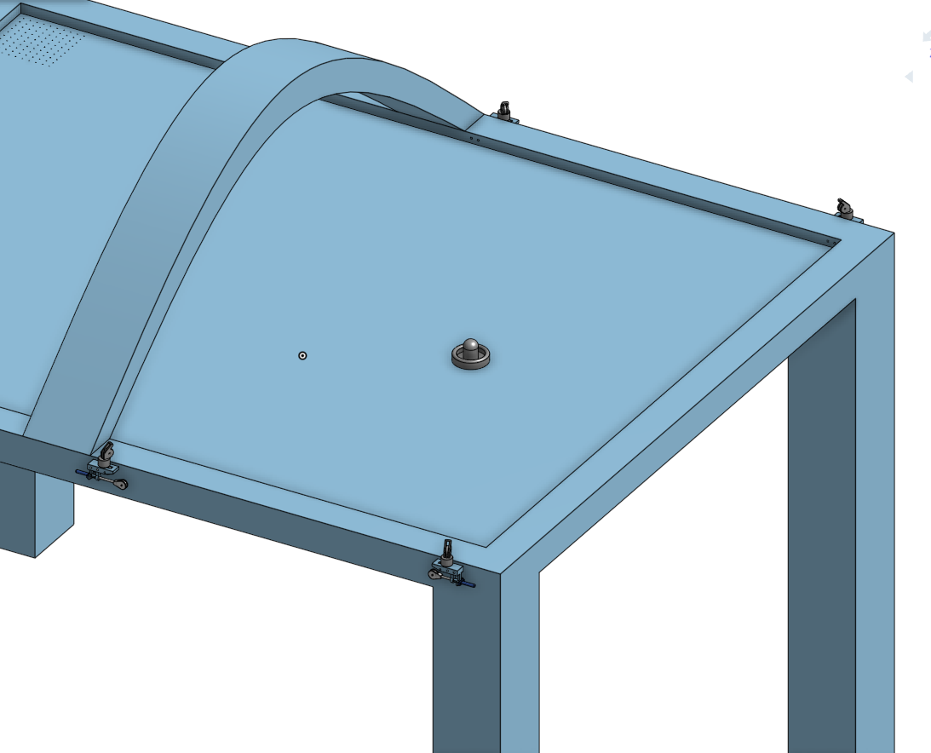

**Image 1**: Air Hockey Table with attached cable tension system and camera mount

**Description**: Each cable tensioner connects with a wire (not shown) to the puck on the play surface. These cable tensioners are then run into stepper motors to create a 2D plane of numeric movement control. The camera to detect puck location is then mounted to the arched beam at midfield.

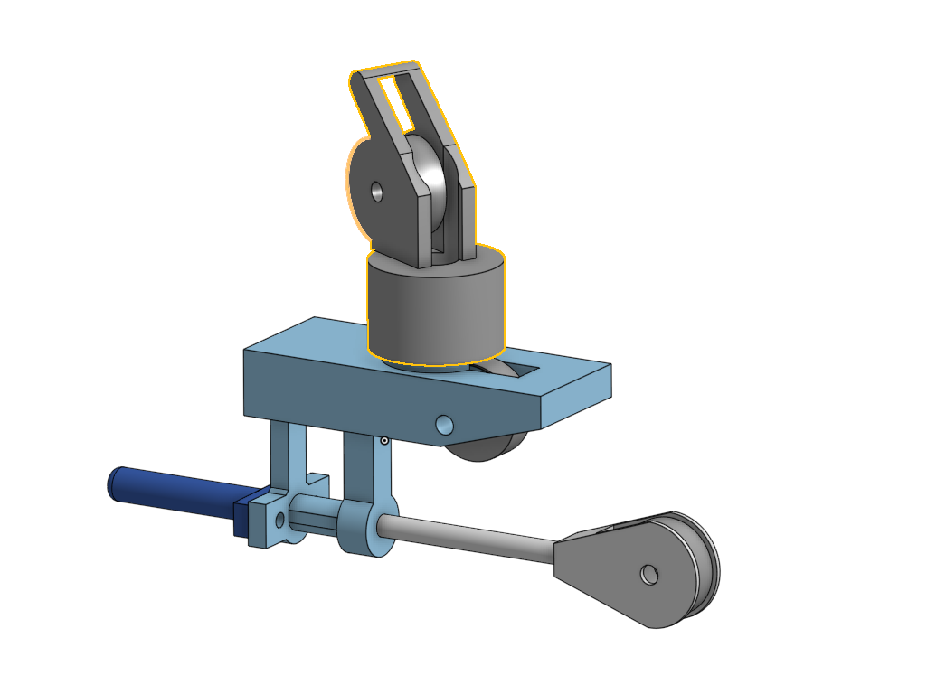

Image 2: Cable Tension system

**Description:** To give ~5 cm of cable length tolerance, each cable is run through the following tensioning system. If the stepper motor does not pull enough cable into the spool, this system ensures that the cable will remain tensioned up to a maximum +/- 2.5 cm from actual required length.